NHS Cancer 62 Day treatment Dashboard

User Guide

[Cancer Dashboard | Tableau Public](https://public.tableau.com/app/profile/ahad.samad.khan/viz/CancerDashboard_16825454747130/Dashboard1?publish=yes)

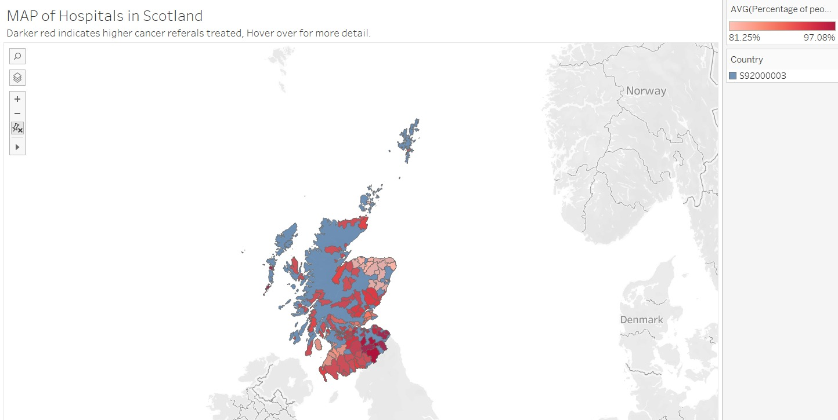

The first tool that a user can see on the Dashboard is the map. Which shows the country Scotland highlighted in blue colour. While the red colour indicates the patients who have received the initial treatment in 62 days of referral. The darker the colour red the higher the percentage. More information is available if the user hover around.

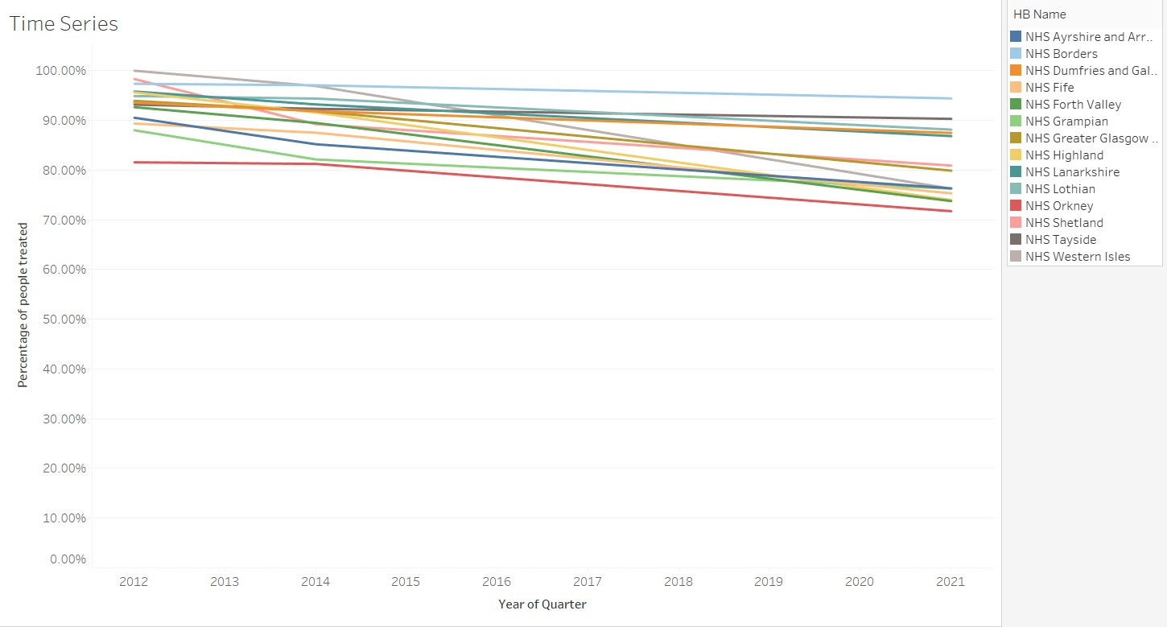

Moreover, the second tool which the user can interact with is the time series. Which shows the overall trend of referral rates in different Health Boards.

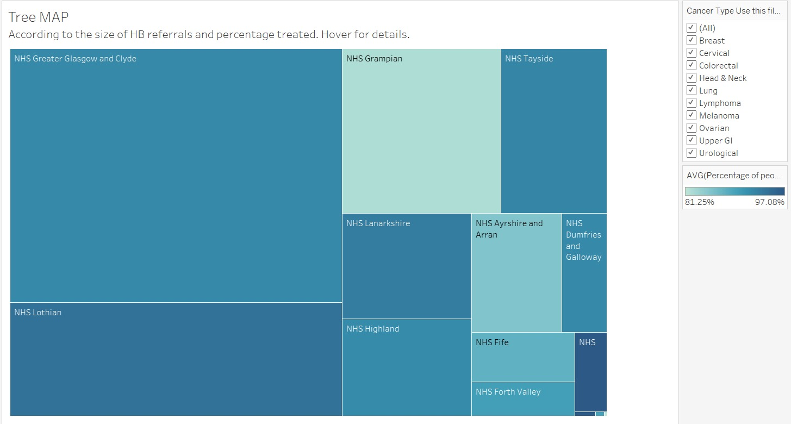

Furthermore, a tree map is available. Which shows the size of different Health Boards across Scotland. It also shows the percentage of patients treated.

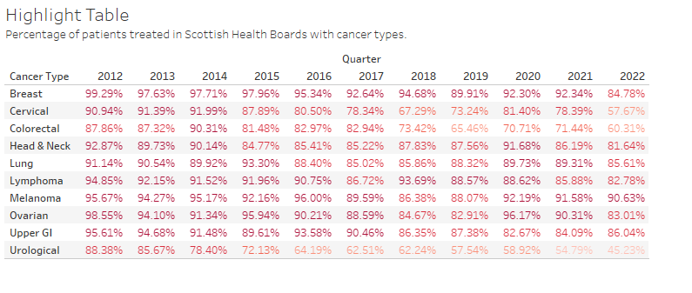

Lastly a highlight table indicates the cancer treatments which have successfully treated 90% or above referred pateints and the ones that have failed. The dark red color indicates success while the light red color would mean failure. Percentages are labelled so that it can be indicated clearly which ones failed and which were successful.

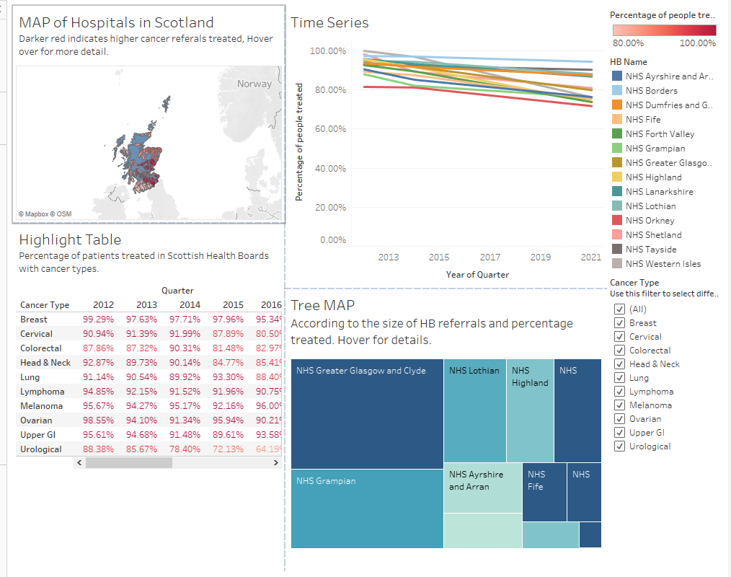

The Dashboard design is kept simple so that the key requirements are made visible. Moreover, action has also be added on the Highlight table. Which would give corresponding information on Map and Tree Map, if hovered around on highlight table. Other that a filter is also given if there is a need to view specific data in accordance to the cancer type.